**::C++ 25 Fall 2016:: Assignment 3 Internet GUI and Hello World**

**Name:** P. Nigel Brown

**Student ID:** 10831438

**Syntax-** Proper application of a particular language. For example, in the English language,

**(write a sentence that has incorrect syntax, but correct semantics) -**

What chips they got at the store?

**Semantics**- The author’s intended meaning

**(write a sentence that has correct syntax, but incorrect semantics) -**

Wear is the buffalo?

**Why does the syntax and semantics in computer programming have to be exact?**

In order to get a predictable output.

**Source Code-** The software language written by the programmers to create an executable file.

**Machine Code-** The 1’s and 0’s that communicate with the computer’s hardware.

**Compiler-** Turns source code into instructions for the computer hardware to carry out.

**Section 2: WRITING PROGRAMS**

**main () –** A function that signals the start of program execution.

**Code block-** A chunk of code (several line) that is grouped together. This is done with braces. {}

**Comments-** Notes from the programmer to the reader of the source code. They are usually explanatory so someone reading your code will understand what you’ve done and why you’ve done it. The compiler skips over these statements.

**Functions-** Blocks of code that can be called to perform a specific operation.

**Cout** Character Output. Indicates that the computer should display some text.

**<<-** Insertion operator. Sends the text to the right of these angled brackets to the display.

**endl-** Begins a new line of text.

**;** Signals the end of a statement. Goes at the end of every instruction.

**How does the IDE make your programming life easier?** The IDE knows the language and its limitations. It can help catch errors before they become problematic. The IDE also often has a compiler that will translate your source code into the machine code the computer needs to execute your program.

**LAB ASSIGNMENT**

Focused on IDE Development

Take the directions from Assignment 2 Lab Assignment and execute in a C++ IDE.

Include snipping photo of source code and command prompt output. (Hint… the window will not remain open so you need to find a line of code that will allow the window to remain open so you can take a screenshot.)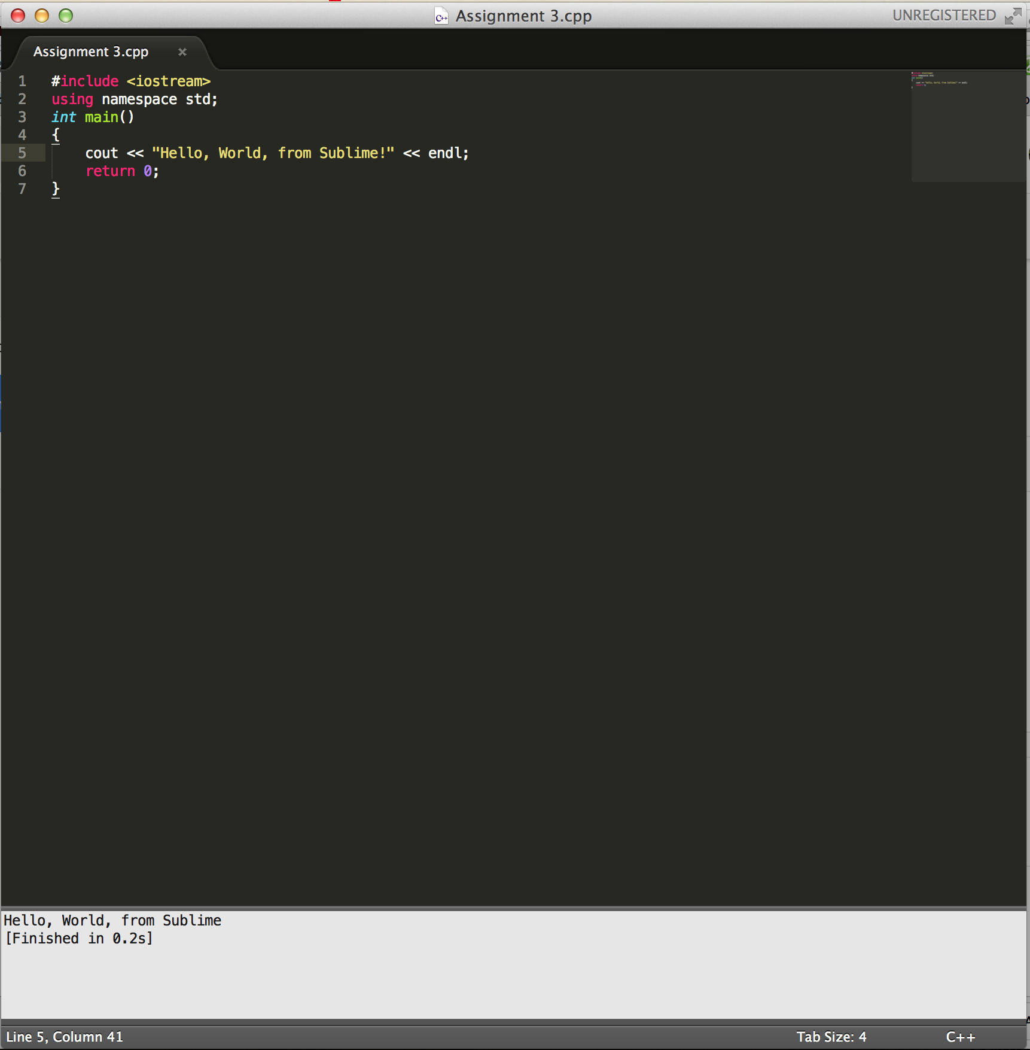

Using sizeof() method to create a program that will output the size char, int, short int, long int, float, double, wchar-t.

Include snipping photo of source code and command prompt output.